St. Aloysius – St. Agatha Century Capital Repair Campaign

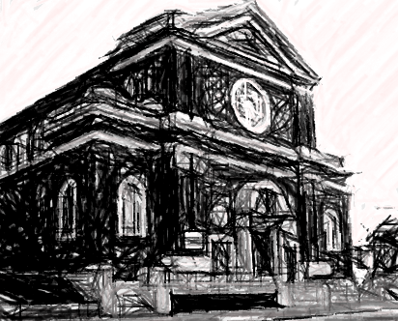
MY GIFT June 2018- June 2021
NAME ______________________________________________________
ADDRESS ____________________________________________________
CITY | STATE | ZIP _____________________________________________
PHONE _____________________ EMAIL ___________________________
TOTAL GIFT $ _____________________
How do you wish to make your gift?
$ __________ one-time payment
$ _________ monthly FOR 36 months
$ __________ yearly FOR 3 years
$ __________ other FOR __________
__________ I am interested in electronic giving options

I/We wish to give to the “Century Capital Repairs” Campaign by means of a gift other than cash.
Required Minimum Distribution ______________ Stock Gift ________________ Total $ ___________________
Signature ____________________________________________________ Date __________________________

